

**UNIVERSITY OF PETROLEUM & ENERGY STUDIES**

**SCHOOL OF COMPUTER SCIENCE**

***Department of Cybernetics***

**GRAPHICS AND ANIMATIONS TOOLS**

**LAB FILE**

**SESSION (2020-21)**

**Course: B.Tech with specialization in Open Source & Open Standards**

**Submitted to: Submitted by:**

Dr. Durgansh Sharma Ashish Pandey

Associate Professor SAP: 500063104

Department of Cybernetics Roll no: R100217014

**Experiment 2**

**Aim:** Design a logo using GIMP

**Step1:** Think of a logo that you want to make, and draw it on a paper.

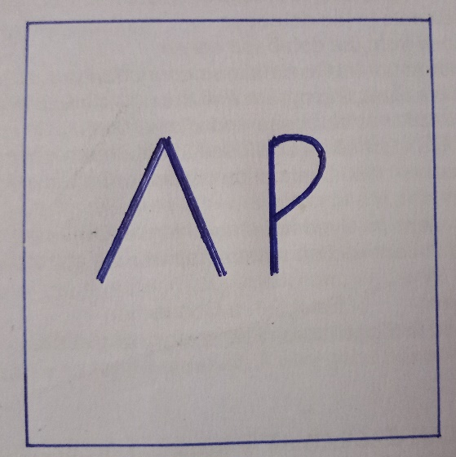

**Step2:** Open GIMP and click on New (Top Left Corner) → Open as layer and open the image of the idea that you have.

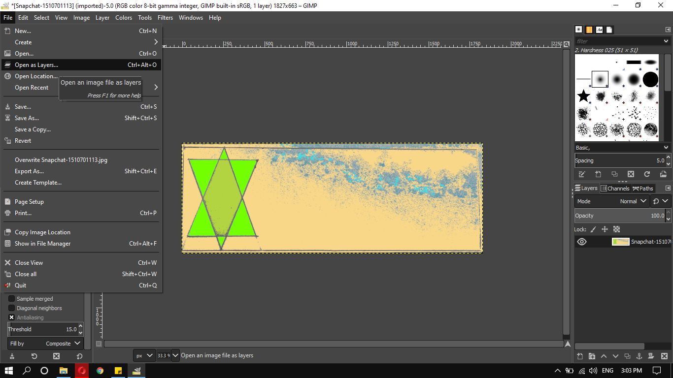

**Step3:** Now, you can edit the image using different tools available on GIMP, add colors using the bucket tool.

**Step4:** After adding the colors, add the text using TEXT TOOL under the toolbox. Add other objects.

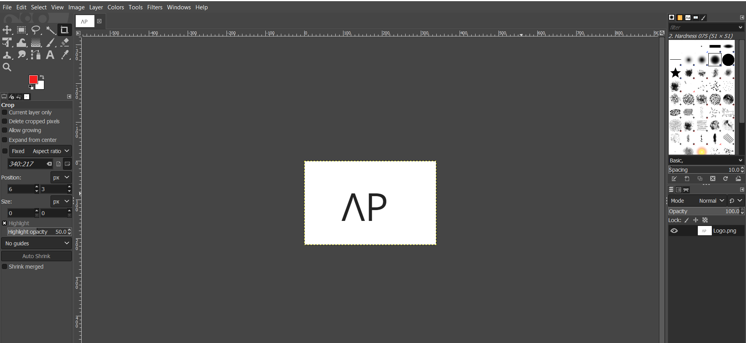

**Step5:** Export the image as .PNG or .JPG.